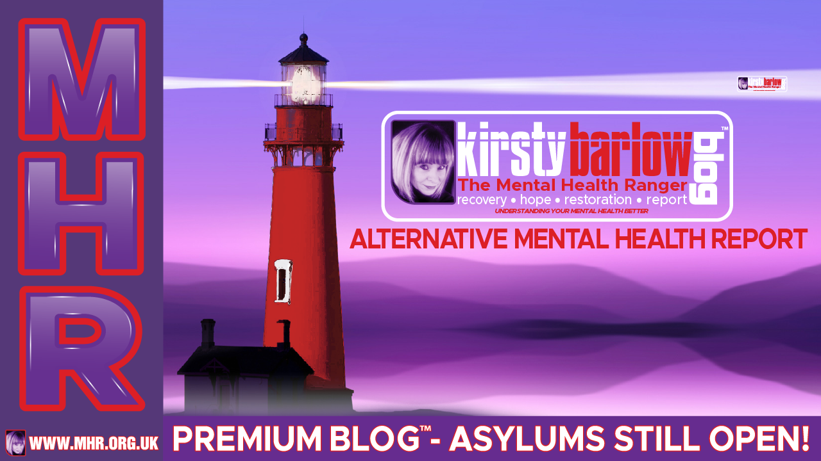

**THE ASYLUMS ARE STILL OPEN – AN MHR™ PREMIUM BLOG**

**THE MENTAL HEALTH RANGER™**

The Mental Asylums are still open, they are used as a threat, a lever to coerce, an unseen threat that if you do not take your medication or conform to our social norms and expectations, you will be detained!

The number of people being detained has risen steadily over time, without scrutinising and analysing data too much. I think that sad truth is for many reasons. The official NHS data showed a slight decrease in admissions under the Mental Health Act (!983) last year (2021) of 5% although I am sceptical about those statistics for many reasons.

Firstly, that many admissions are now via private hospitals who do not record and report admissions in the same way or as efficiently as an NHS provider. Secondly, there remains a high proportion of people “waiting for a bed” at any one time, meaning they are ‘detainable’ and should be in hospital but are still in the community being cared for by their Community Team and Family.

Admissions are also shorter than they used to be and are more frequent, some people being detained on a frequent basis when they feel they can no longer keep themselves safe along with impersonal and over stretched community services.

This alongside rapidly fragmented community support and an overemphasis on medication and the ‘medical model’ for the last 2-3 decades have all contributed to the current mental health “crisis” of services.

As many of you know, I have practiced as an Approved Mental Health Professional (AMHP) in the UK and I have detained people when they have been at their absolute worst and there has been no safe community alternative available and unfortunately, I do believe that that role is sometimes necessary.

People do, at times when they are unwell, need to be in a place of safety, where they can be sheltered and protected from harm and the harm that they could cause themselves, which could possibly be irreparable but this should be more of a safe haven.

It should not become your worst nightmare, where medication is still forcibly given, you can be exposed to horrors like you have never even dreamt of, as you see other people at their worst, either in a psychotic state or franticly fighting with staff who are trying to impose “policies” for their own “safety and security”.

I am speaking from experience here, I have spent many a night on the Psychiatric Wards, comforting people that I have detained, ensuring that there is a safe pair of hands that I can hand over to, whilst making sure that friends and relatives are fully informed.

Eventually I could no longer perform this role as the resources were so scarce that it felt unsafe professionally to determine that ‘in your professional opinion’ someone urgently needed to be in hospital but to then having to leave them at home with their family because there were no beds!

The very notion or idea of being in hospital conjures up images of laying down in bed with a jug of water next to you, visitors bringing cards and flowers, nurses tending to your needs with care and compassion, in general being nurtured back to health, whereas in reality, that could not be further from the truth. A psychiatric ward is an extremely intimidating and frightening place for most, especially if you are unwell.

That being said, for some people who have been at home, alone, self neglecting and trying to deal with hearing voices, fear (even terror), lack of sleep and isolation, being in hospital can bring some welcomed relief.

So, considering why the hospitals are continually full, despite politicians constantly ‘banging on’ about how many billions they are investing into “state of the art facilities” and mental health care provision, then why is the situation still so dire?

It is because we, as a society, are creating “patients” with “disorders” which is completely disempowering. Communities have become fragmented for many reasons but what this has created is loneliness, misery, increased poverty, substance misuse and despair. When you medicalise misery and despair, then add into that reduced resilience to cope with it and you have the perfect breeding ground for what you would term as “Depression” or “Personality Disorder” the list is endless and growing every year.

It is society’s responsibility, not just the individual to build healthy minds and resilience. Whilst mental illness is understood as an individual problem, the “chemical imbalance” we will continue to perpetuate a society that creates illness quicker than services could ever cope with it.

So, there are a couple of points here that I believe need to be spoken about, more than they are. Firstly, the notion that emotions, beliefs and feelings can be categorised as a “disorder” or a medical condition and secondly that it is a purely individual battle.

There needs to be a bigger societal shift here away from materialism, success, productivity and academic achievement towards valuing time, family, self-exploration, artistic expression, connection, community, nature, spirituality and inner peace and contentment, that promotes GOOD mental health and resilience and not dependency on pharmaceuticals and then being dependent and identified as disordered and disabled forever!

My ideal alternative to any hospital environment would be a sanctuary of healing, where Psychosocial models of understanding distress and ensuring that a person is treated holistically, incorporating their spiritual needs, social needs and beliefs along with the most important thing of all, being treated with genuine care, compassion, kindness and dignity.

© COPYRIGHT – THE MENTAL HEALTH RANGER™ 2022